**NAXT Quick tips**

**Adding a contact**

*GGZ > Sales and marketing > Common > Contacts > All contacts*

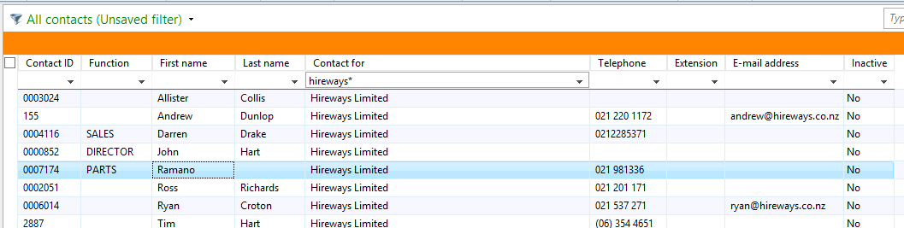

1. **Personalise the Functions column into the grid**
2. Create a contact
3. **Contact** Add a new contact
4. **Contact for** Filter for company name
5. **Select**
6. **Function** Select your department or business unit

e.g. PARTS, SERVICE, MACHINE SALES

1. Update other details
2. **Save and close** Or Select **Save and open** to add notes, or select preferred contact where there is more than one

